NAME : A.VENKATA PRATHAP REDDY

REG NO : 192111428

COURSE : SOFTWARE ENGINEERING

CODE : CSA1001

FACULTY : DR.G.Mary valantina

LIBRARY MANAGEMENT SYSTEM

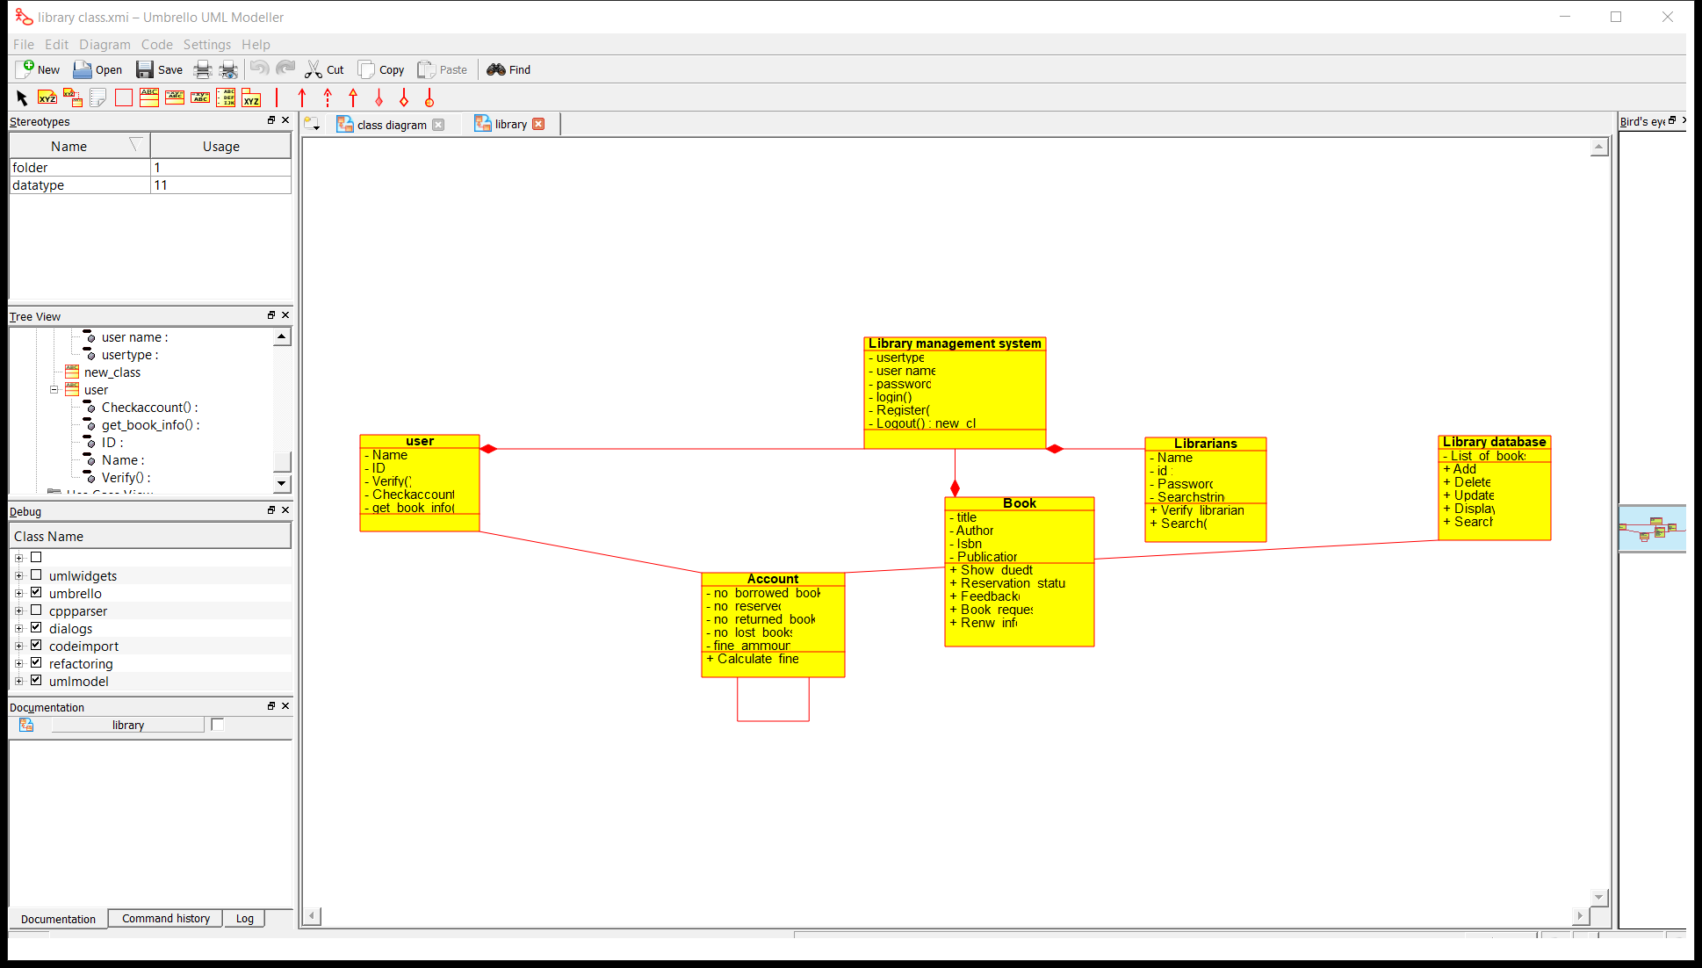

RESULT: I had successfully completed experiment in umbrello software

ONLINE SHOPPING SYSTEM

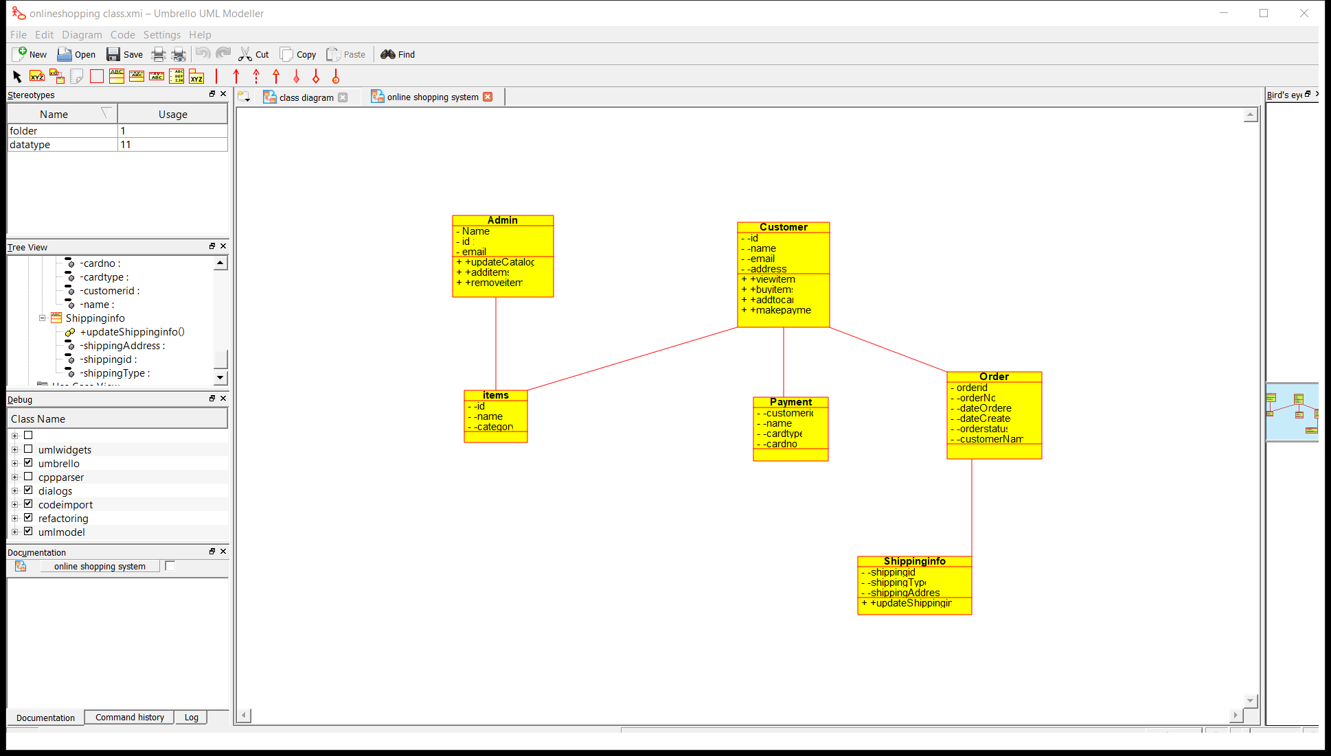

RESULT: I had successfully completed experiment in umbrello software

RAILWAY RESERVATION STSTEM

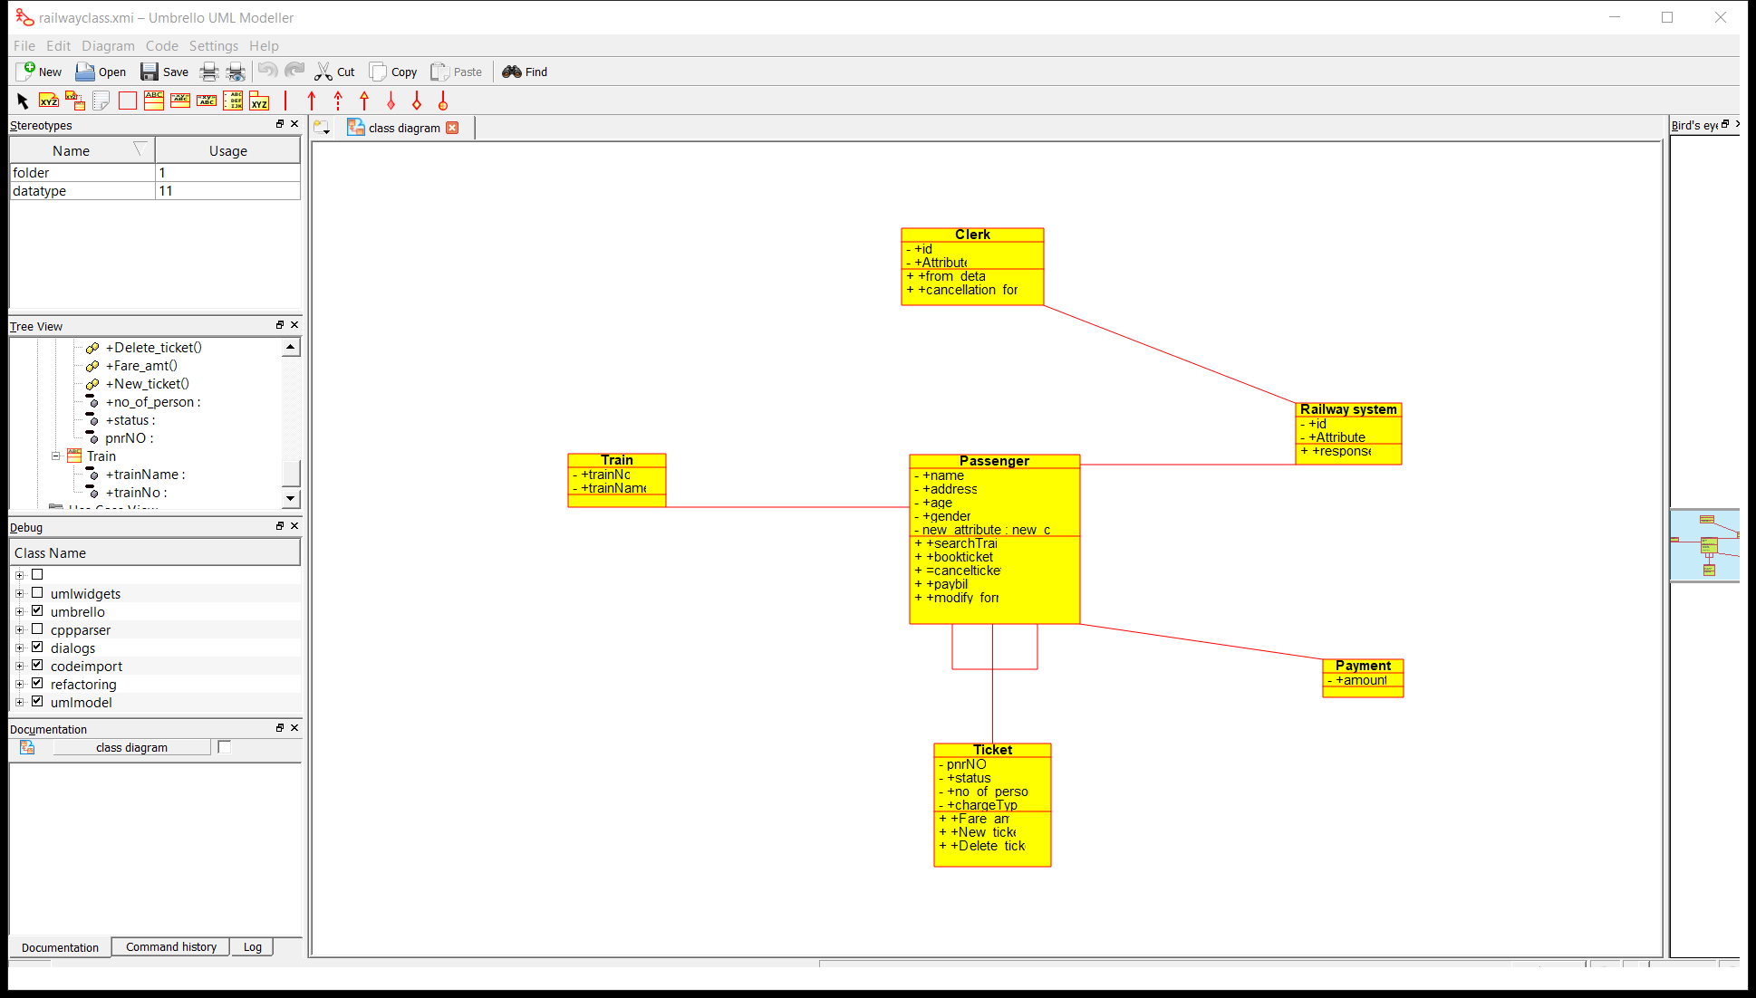

RESULT: I had successfully completed experiment in umbrello software

RAILWAY RESERVATION ACTIVITY DIAGRAM

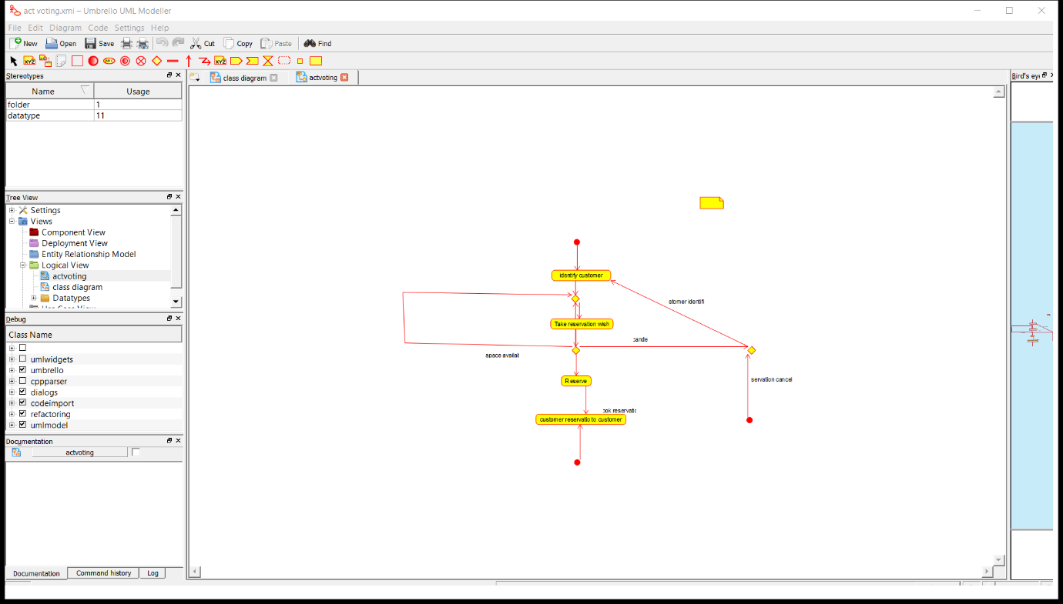

RESULT: I had successfully completed experiment in umbrello software

ONLINE VOTING

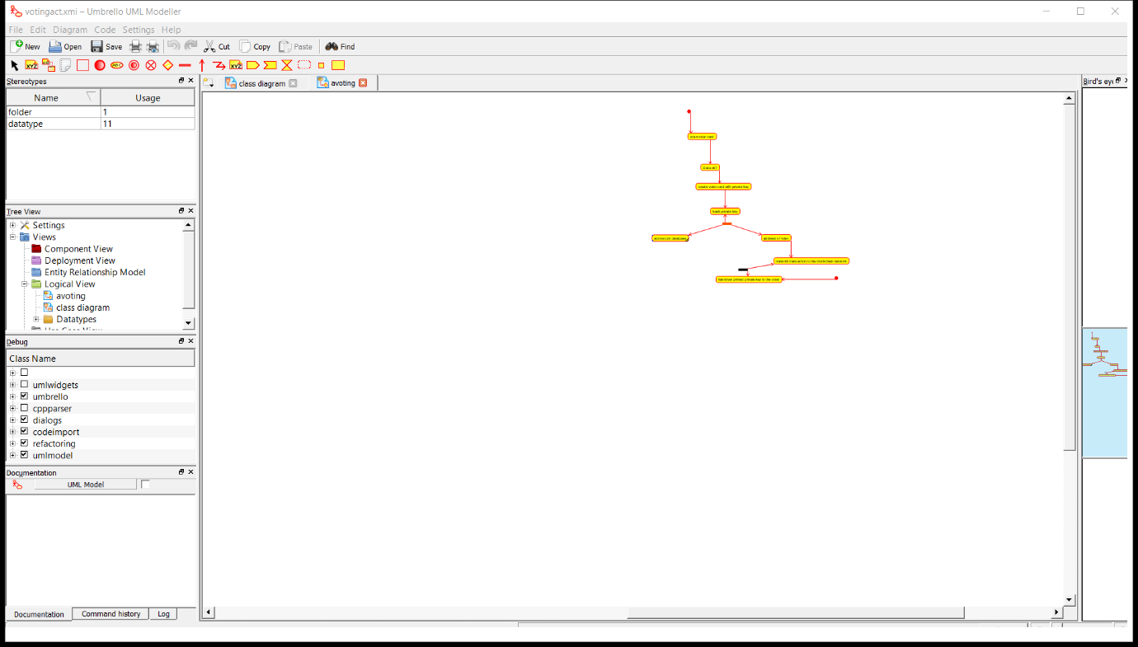

RESULT: I had successfully completed experiment in umbrello software

LIBRARY MANAGEMENT

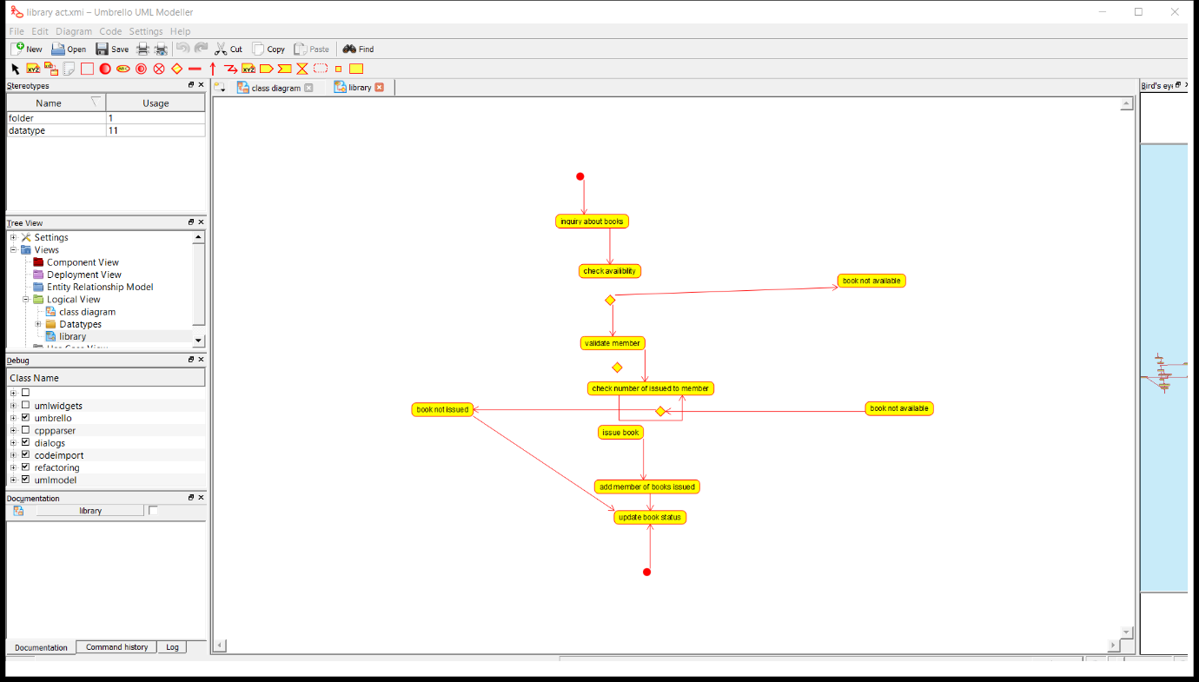

RESULT: I had successfully completed experiment in umbrello software

ONLINE SHOPPING

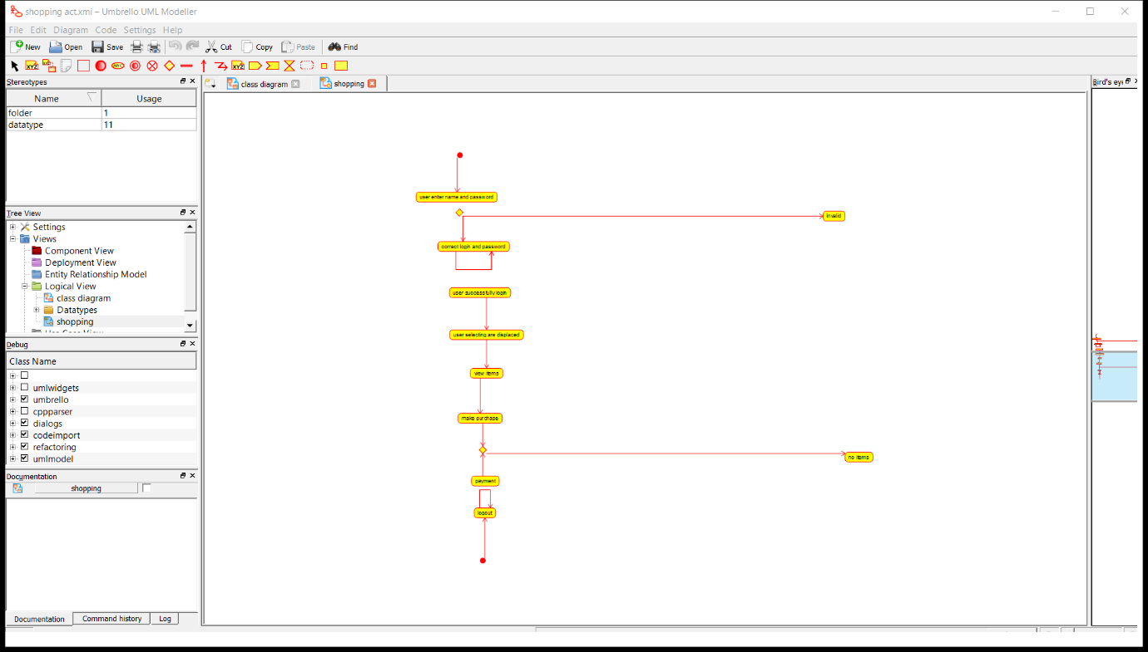

RESULT: I had successfully completed experiment in umbrello software